**Project: Event Management System using PostgreSQL.**

**1. Database Creation**

Create a database named "EventsManagement."

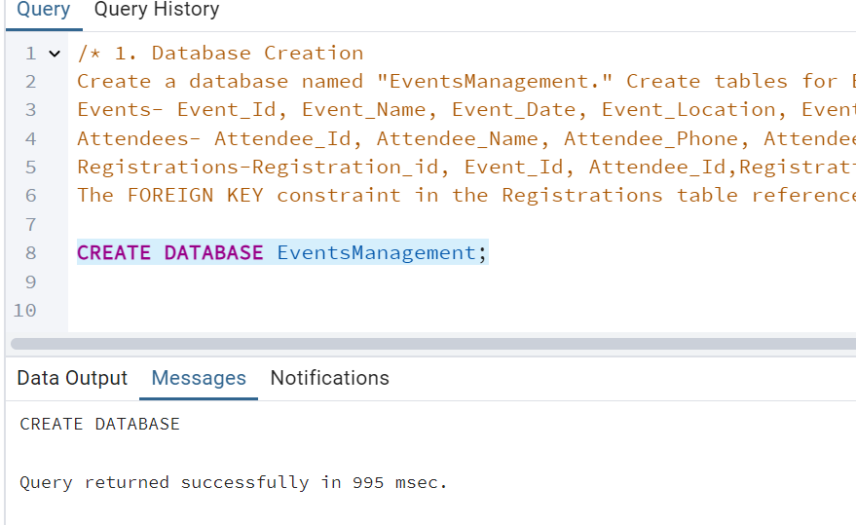

Create tables for Events:

Events- Event_Id, Event_Name, Event_Date, Event_Location, Event_Description

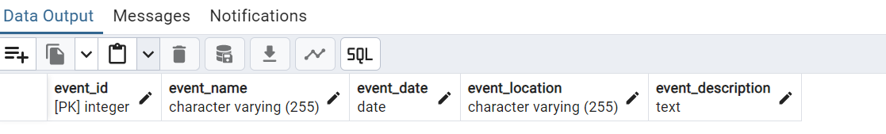

Attendees:

Attendees- Attendee_Id, Attendee_Name, Attendee_Phone, Attendee_Email, Attendee_City

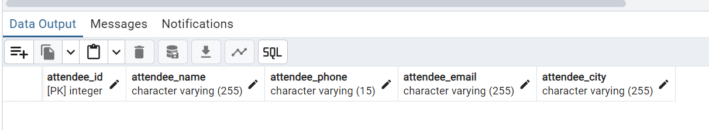

Registrations:

Registrations-Registration_id, Event_Id, Attendee_Id,Registration_Date,Registration_Amount.

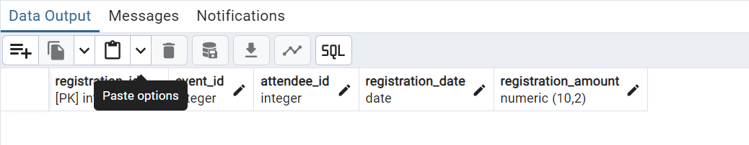

The FOREIGN KEY constraint in the Registrations table references the Event_Id column in the Events table and the Attendee_Id column in the Attendees table.

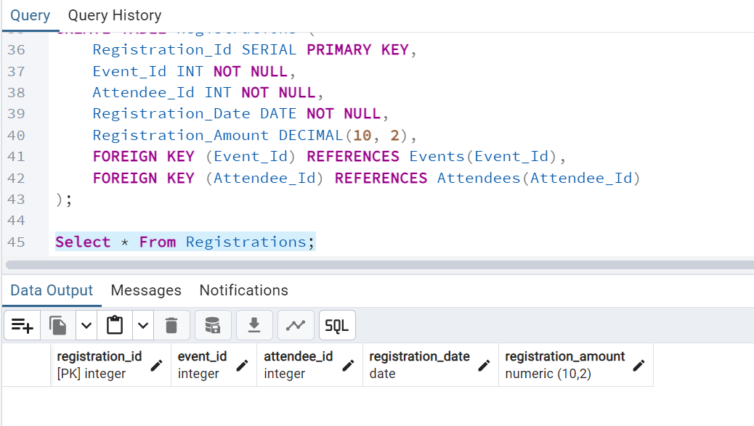

**2. Data Creation**

Insert some sample data for Events, Attendees, and Registrations tables with respective fields.

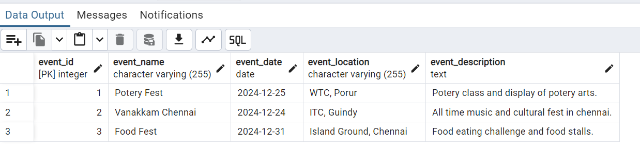

**3. Manage Event Details**

a) Inserting a new event.

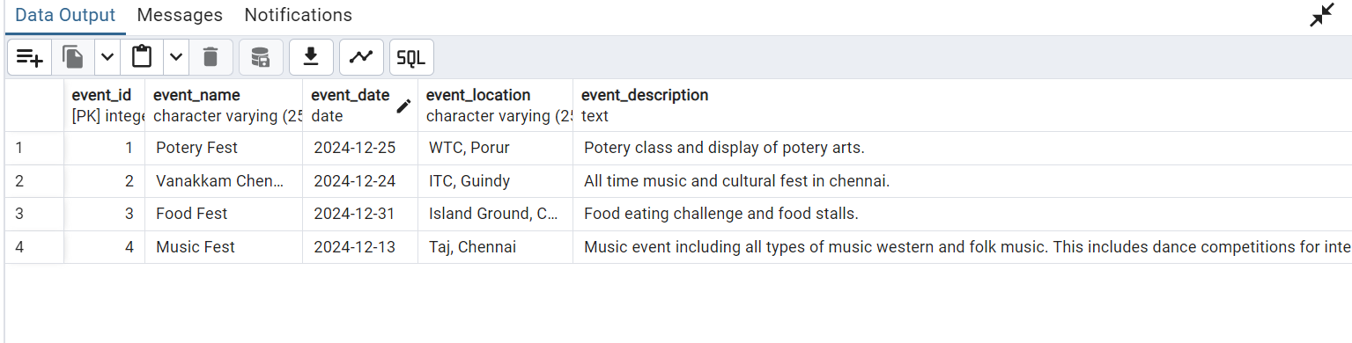

b) Updating an event's information.

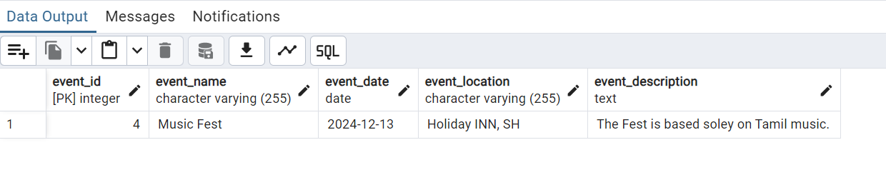

c) Deleting an event.

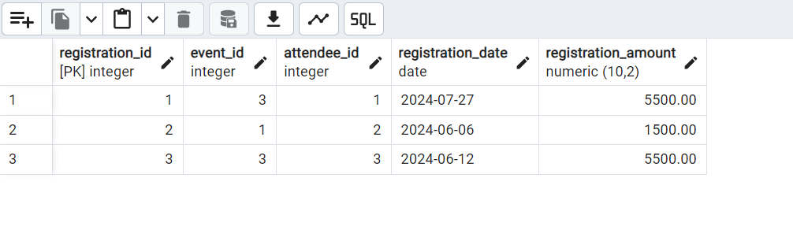

**4) Manage Track Attendees & Handle Events**

a) Inserting a new attendee.

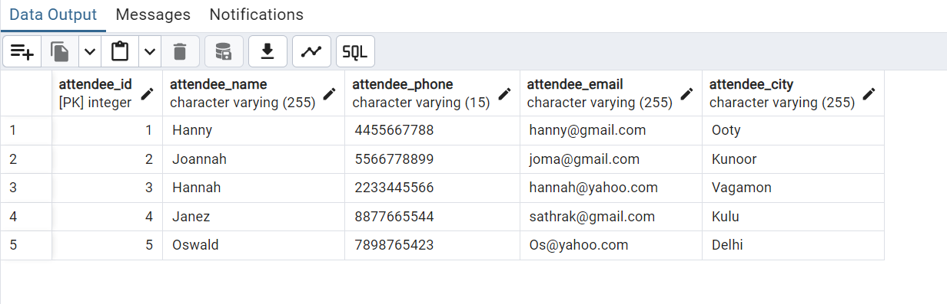

b) Registering an attendee for an event.

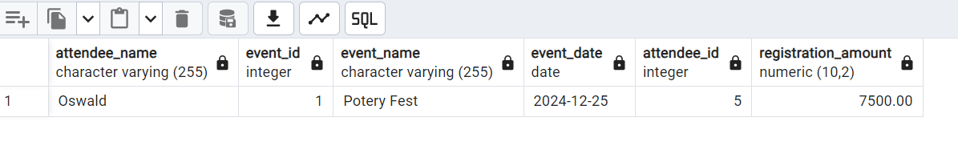

**5.Develop queries to retrieve event information, generate attendee lists, and calculate event attendance statistics.**

